How to Setup Godaddy SSL on AWS EC2

**Step-1**

Generate local key

Generate key in any new folder /home/ec2-user/blvd

Run the command inside blvd folder

$ sudo openssl genrsa -out localhost.key 2048

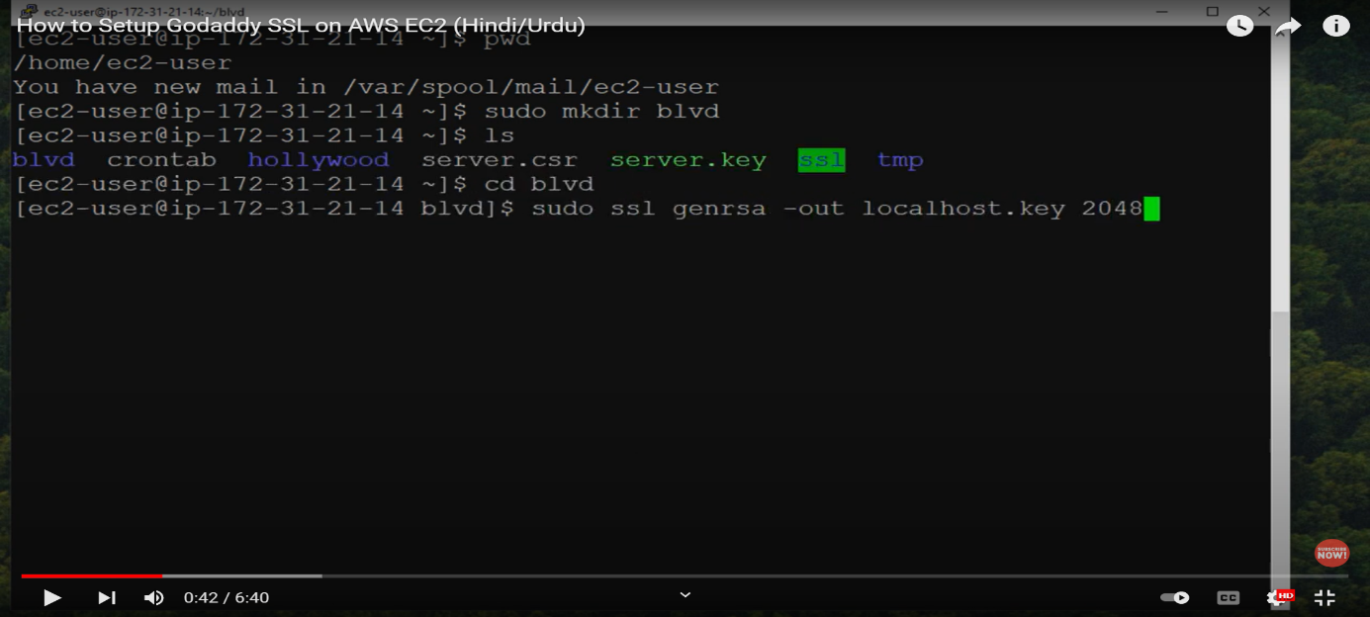

Local key in side folder

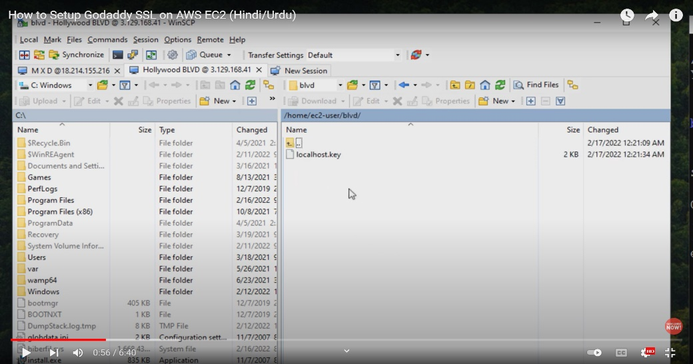

**Step-2 Request for csr**

Run the command

$ sudo openssl req -new -key localhost.key -out csr.pem

After this command fill the detail accordingly required

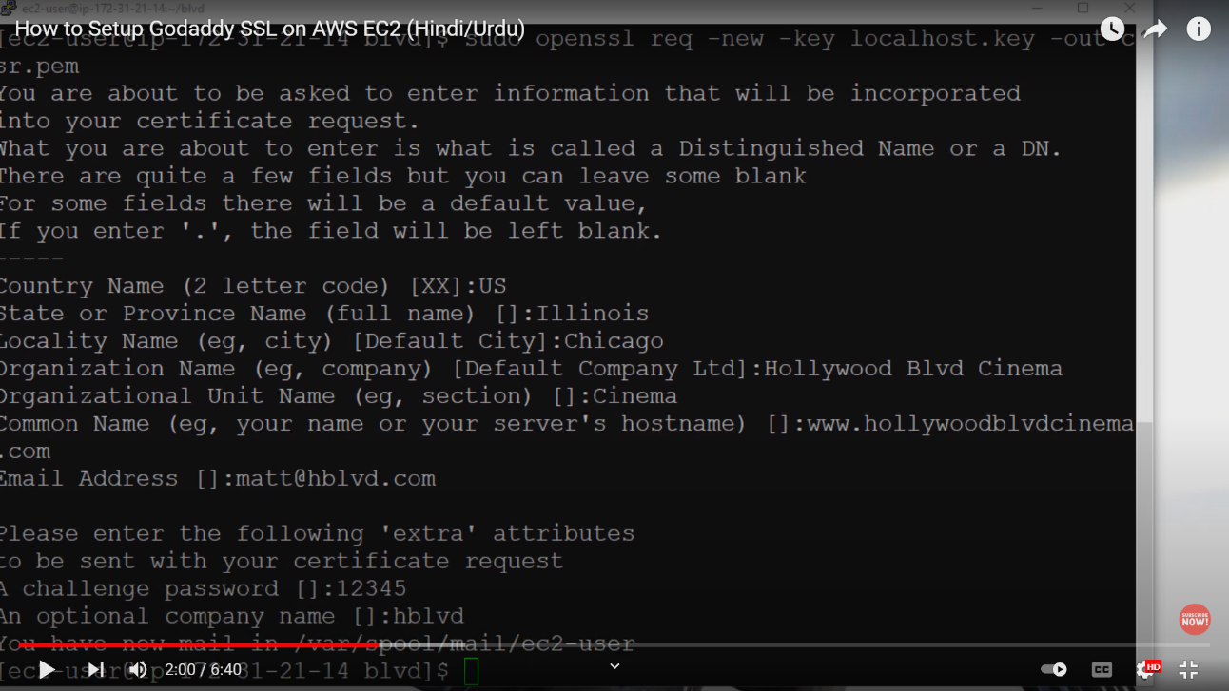

**Step-3**

Open csr in edditor and login to godaddy => ssl certificate => under drop down manage domain.  
Copy and past csr key to Re-Key you certificate then Add change and submit and done.

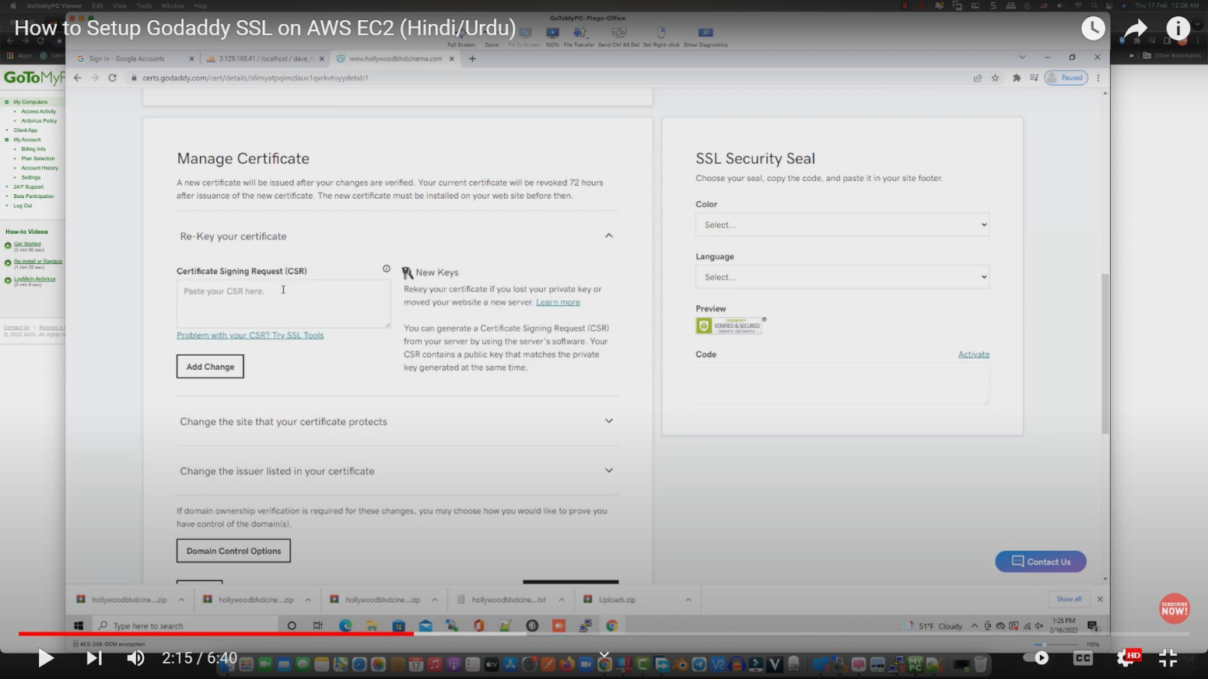

**Step -4**

After submitting refresh the page where you get download zip option select as your server type.

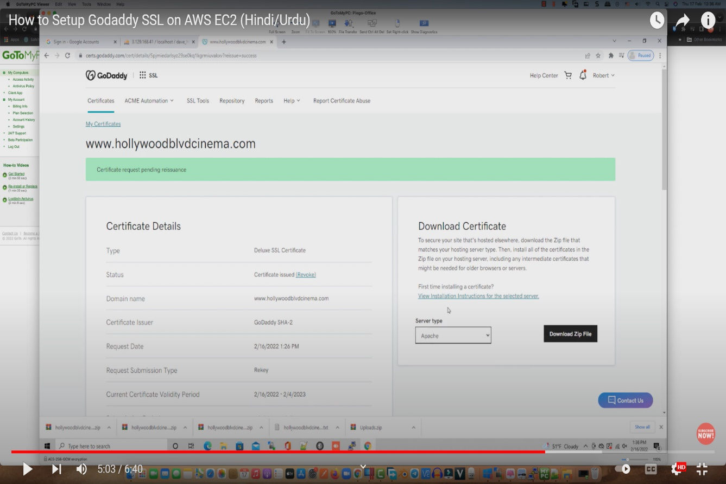

Now locate the ssl.conf. In my case it was in /etc/apache2/sites-available

**Step -5**

$ sudo nano ssl.conf

Open and change the path for

SSLCertificateFile /home/ec2-user/blvd/localhost.crt

SSLCertificateKeyFile /home/ec2-user/blvd/localhost.key

SSLCertificateChainFile /home/ec2-user/blvd/gd_bundle-g2-g1.crt

Before change unzip rename the file and move the both .crt file to blvd folder with the name

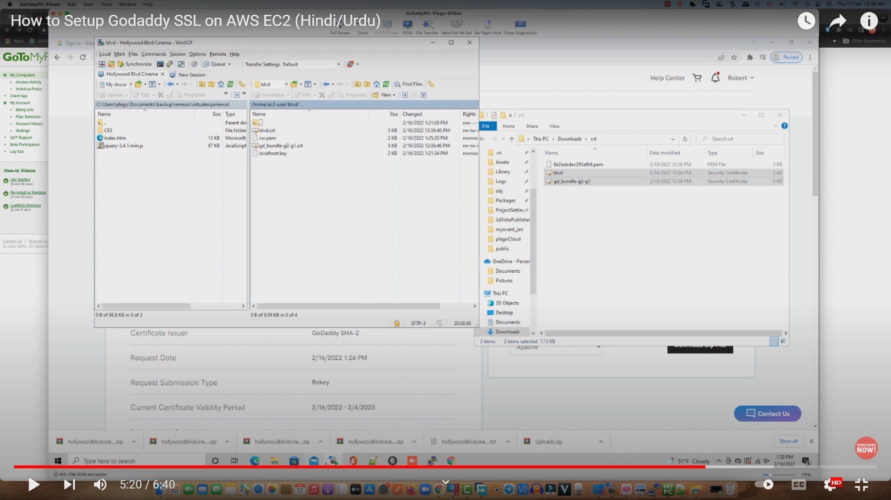

**Step -6**

Save and exit

**Step -7**

$ sudo systemctl restart apache2

Done Check the Website.  
  
Video Link <https://www.youtube.com/watch?v=ovP9h3JUyQE>